Zuhair Ahmed May 23, 2021

CS372_400_Spring 2021

**Project Traceroute**

To run using macOS and Python3 (must have root privileges/access) open Terminal and input:

sudo python3 traceroute.py

To run different website, simply uncomment (or input your own unique one) at bottom of main function.

**Ping + Traceroute Test Screenshots:**

1. [www.google.com](http://www.google.com) (USA)

1. [www.amazon.com](http://www.amazon.com) (USA)

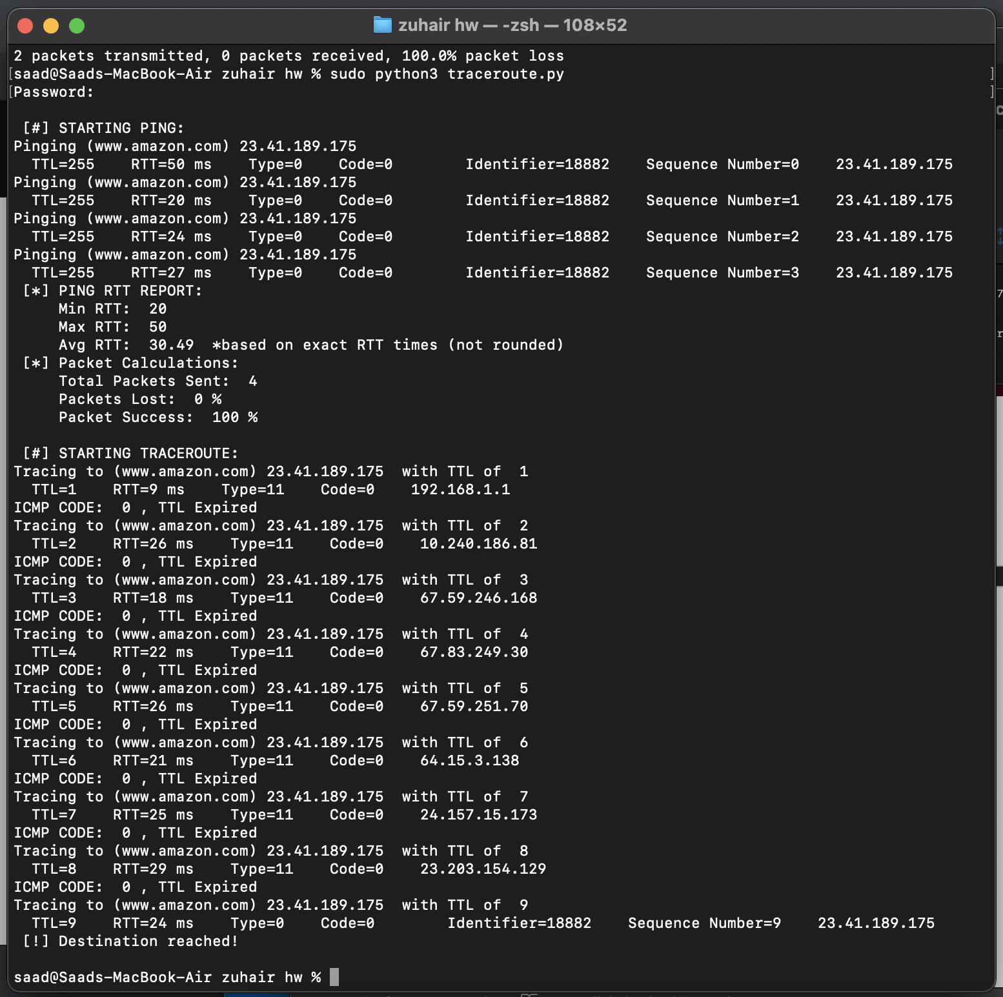

1. [www.baidu.com](http://www.baidu.com) (China)

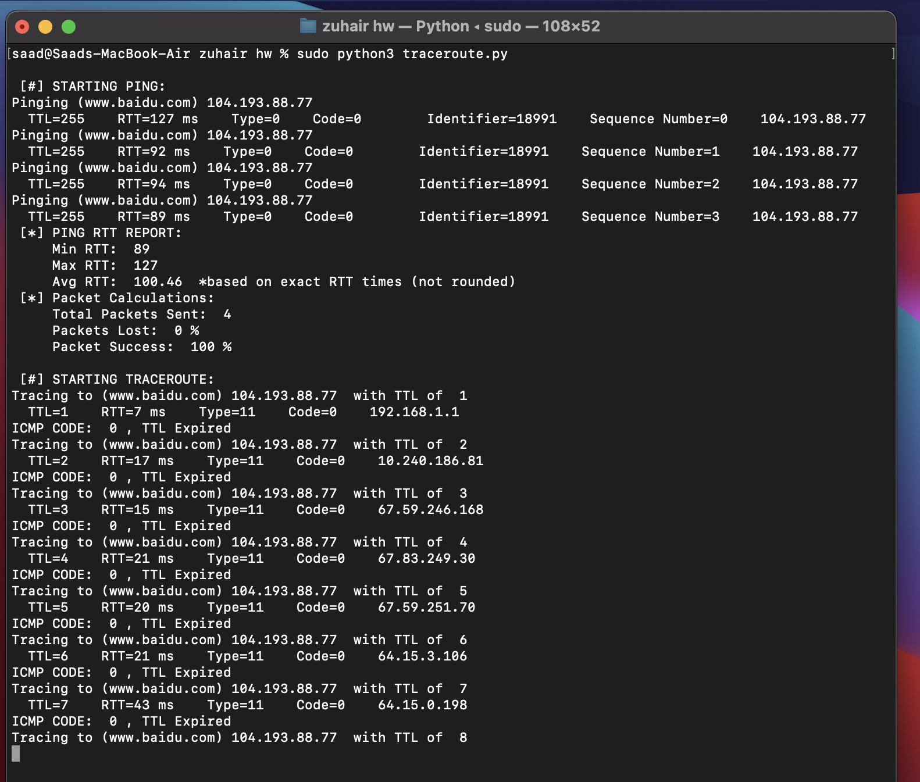

1. [www.google.com.br](http://www.google.com.br) (Brazil)

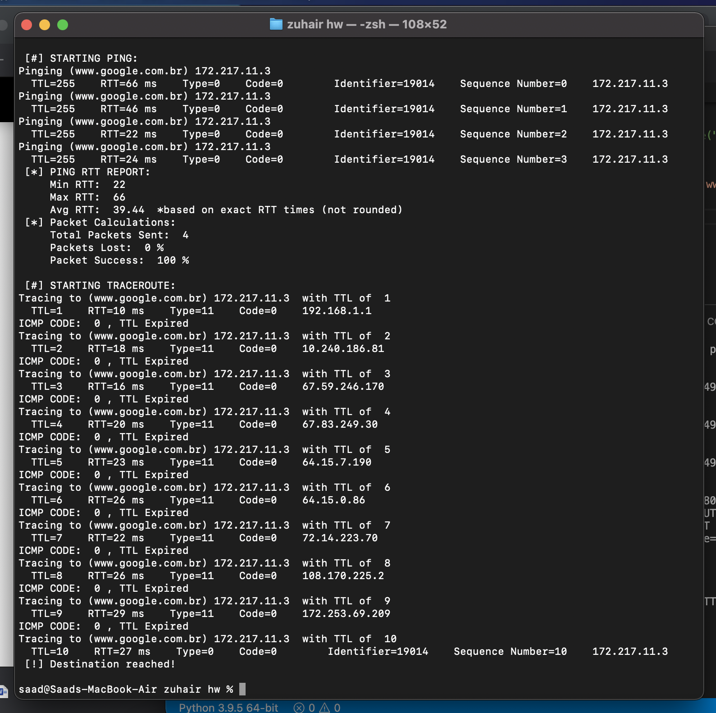

1. [www.amazon.de](http://www.amazon.de) (Germany)

